LAB 7

EXCEPTION HANDLING

1.

package com.company;  
import javax.naming.NameNotFoundException;  
import java.lang.Math;  
import java.util.Scanner;  
public class SqrtException { public static void main(String[] args){  
 Scanner n= new Scanner(System.*in*);  
 System.*out*.println("Enter number: ");  
 double x= n.nextDouble();  
 try{  
 x=Math.*sqrt*(x);  
 if(x>=0)  
 System.*out*.println("Sqr root: "+x);  
  
 else  
 throw new ArithmeticException();  
 }  
 catch(ArithmeticException e){  
 System.*out*.println("Square root of negative numbers can't be found");  
 }  
 }  
}

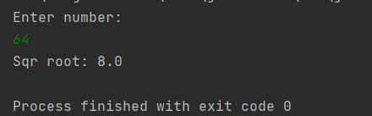

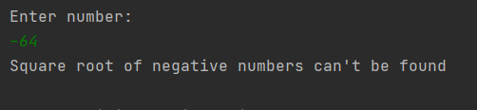

2.

package com.company;  
import java.lang.Double;  
import java.util.Scanner;  
public class ParseException {  
 public static void main(String[] args){  
 Scanner n= new Scanner(System.*in*);  
 try{  
 System.*out*.println("Enter String: ");  
 String a=n.nextLine();  
 double b;  
 b=Double.*parseDouble*(a);  
 System.*out*.println("Converted Double: "+b);  
 }  
 catch(NumberFormatException e){  
 System.*out*.println("The string can't be converted into a Double");  
 }  
 }  
}

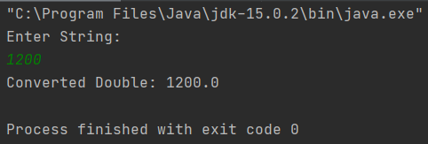

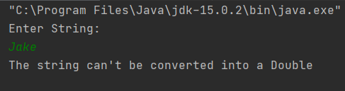

3.

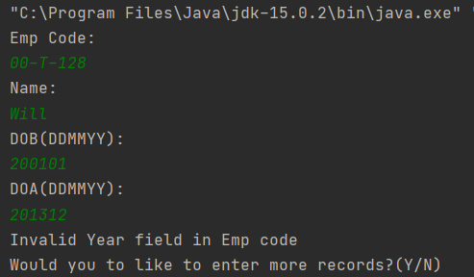

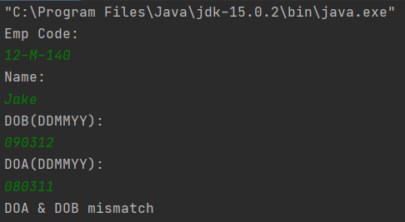

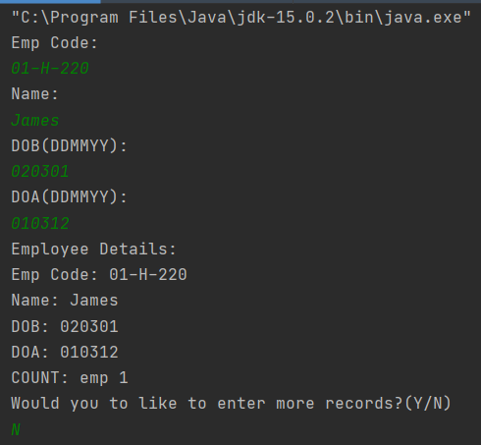

package com.company;  
import java.util.Scanner;  
import java.lang.String;  
  
class Myexception extends Exception{  
 public Myexception(String a){  
 super(a);  
 }  
}  
class Employee{  
 public static int *count*=0;  
 String empcode, name, dob, doa;  
 void read(String empcode, String name, String dob, String doa){  
 this.dob=dob;  
 this.name=name;  
 this.empcode=empcode;  
 this.doa=doa;  
 *count*++;  
 }  
 void display(){  
 System.*out*.println("Employee Details:\n"+"Emp Code: "+empcode+"\nName: "+name+"\nDOB: "+dob+"\nDOA: "+doa);  
 System.*out*.println("COUNT: emp "+*count*);  
 }  
}  
  
public class Empcode {  
 public static void main(String[] args) {  
 Scanner n = new Scanner(System.*in*);  
 boolean run = true;  
 char choice;  
 while (run) {  
 try {  
 String empcode, name, dob, doa;  
 System.*out*.println("Emp Code: ");  
 empcode = n.nextLine();  
 System.*out*.println("Name: ");  
 name = n.nextLine();  
 System.*out*.println("DOB(DDMMYY): ");  
 dob = n.nextLine();  
 System.*out*.println("DOA(DDMMYY): ");  
 doa = n.nextLine();  
 String desig1 = "MAHET";  
 char x = dob.charAt(4);  
 char y = dob.charAt(5);  
 int flag = 1;  
 if (empcode.length() == 8) {  
  
 if (empcode.charAt(0) != x || empcode.charAt(1) != y) {  
 throw new Myexception("Invalid Year field in Emp code");  
 }  
 for (int i = 0; i < 6; i++) {  
 if (empcode.charAt(3) == desig1.charAt(i)) {  
 flag = 0;  
 break;  
 }  
 }  
 if (flag == 1) {  
 throw new Myexception("Invalid Designation field in Emp code ");  
 }  
 } else  
 throw new Myexception("Emp code must contain 8 characters");  
 if ((dob.charAt(4) > doa.charAt(4) || (dob.charAt(4) == doa.charAt(4) && dob.charAt(5) > doa.charAt(5)))) {  
 throw new Myexception("DOA & DOB mismatch");  
 }  
 Employee e = new Employee();  
 e.read(empcode, name, dob, doa);  
 e.display();  
 } catch (Myexception e) {  
 System.*out*.println(e.getMessage());  
 }  
 System.*out*.println("Would you to like to enter more records?(Y/N)");  
 choice=n.next().charAt(0);  
 if(choice=='N'){  
 run=false;  
 }  
  
 }  
 }  
}